LNMIIT IEEE AP-S Student Branch Chapter
Tabs
- Home
- Achievements
- Events
- Faculty members
- Student members
- Contact
Home Page
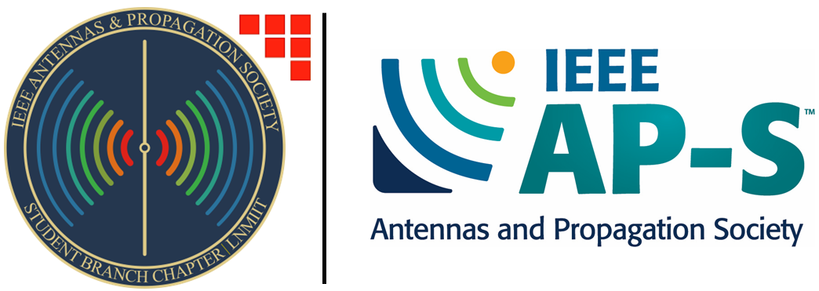
What We Aim to Achieve
We aim to empower students in RF and electromagnetics, build a strong IEEE AP-S community at LNMIIT, encourage more students to become IEEE AP-S members, and enable them to participate in student design contests and conferences while representing LNMIIT on national and international platforms.
What We Do
We support students at every stage of their journey, from discovering RF and electromagnetics to contributing to the IEEE AP-S community.
- Technical Activities: Discover the Field
- We organize talks, symposia, workshops, seminars, and technical discussions on RF, antennas, electromagnetics, and wireless technologies.
- These activities help students, especially newcomers, explore RF and electromagnetics, discover their interests, and become part of the IEEE AP-S community.
- We also organize knowledge camps and outreach activities to introduce school students to RF engineering and its applications.
- Learning & Development: Build Knowledge & Skills
- We guide interested students on relevant courses, projects, internships, career paths, and higher studies opportunities.
- We promote practical learning through simulation, fabrication, and testing of RF and electromagnetics projects, which may include collaboration with other institutes when required.

- Competitions & Professional Exposure: Showcase Your Work
- We mentor and support students to participate in Student Design Contests, conferences, and other technical competitions.
- These opportunities allow students to present their work, exchange ideas with the wider RF community, learn from researchers and professionals.
- Community & Networking: Contribute to the EM Community
- Through IEEE AP-S, students build connections with faculty, researchers, alumni, and industry professionals, opening opportunities for collaboration, mentorship, and professional growth.
- As members gain experience, they take on leadership roles, mentor junior students, and help shape the future of the chapter.

Achievements:
WAMS 2026 Student Design Contest – Winner
Our team, comprising Roopeshwar Megadula, Aryakumar Parmar, and Nandani Sharma, under the guidance of Dr. Jeet Ghosh, was recognized as the Winner of the IEEE WAMS 2026 Student Design Contest for designing, fabricating, and testing a low-profile wideband electromagnetic absorber.
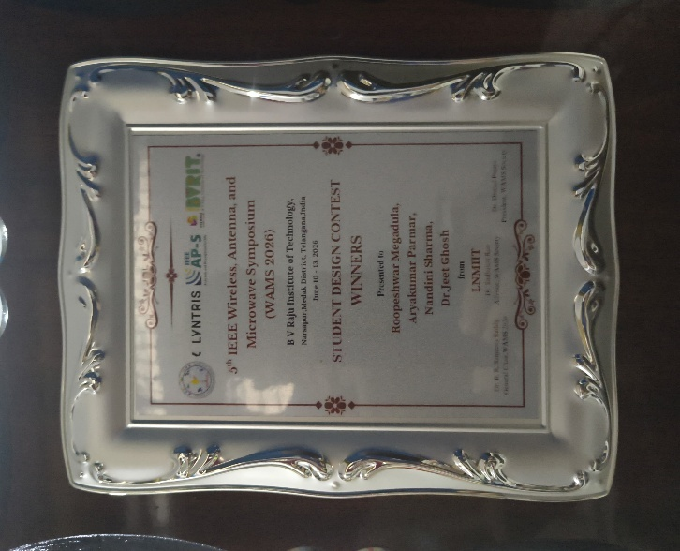 | 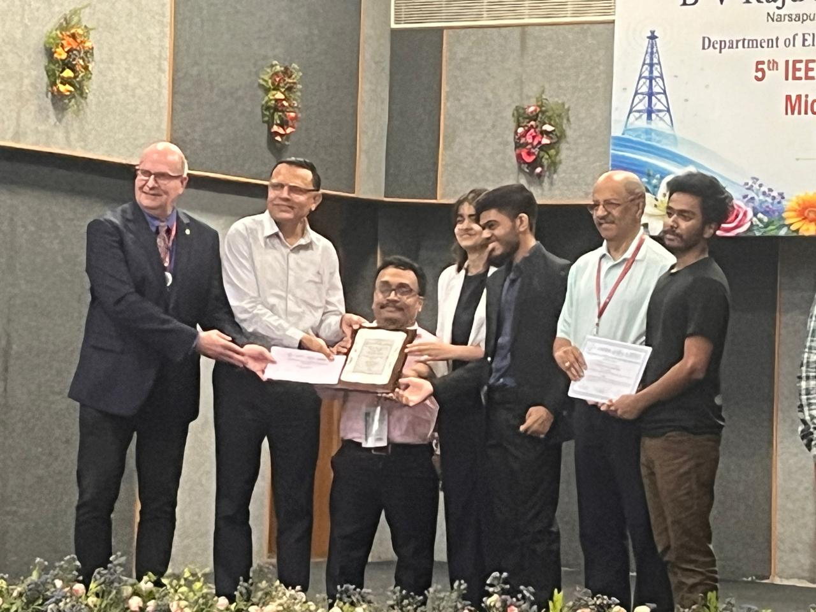

Events:
Current Events:
Past Events:

Faculty members:
Faculty members
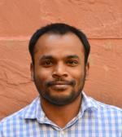  Linkedin profile link | Dr. Gopinath Samanta is working as Assistant Professor (Level-12) in ECE department at The LNM Institute of Information Technology, Jaipur. He joined LNMIIT on 6th July 2021. He completed PhD in 2019 from Indian Institute of Engineering Science and Technology, Shibpur, Howrah, India. He did his PhD work on the design and implementation of Implantable Antenna. Dr. Samanta has post PhD teaching experiences of more than five years. He also served at C V Raman Global University, Odisha and at NIT Sikkim (contractual) after PhD. Dr. Samanta has good number of publication in IEEE transaction on antenna and propagation, IET MAP, Scientific Reports, OPTIK. Elsiver, etc. Dr. Samanta is a regular reviewer of IEEE Transaction on Antenna and Propagation, IET MAP, IEEE Access, IEEE Antenna and Propagation Letter, etc. The research of Dr. Samanta includes, implantable and wearable antenna, Wireless Power Transfer System, Rectenna, Measurface and metamaterials, THz antenna, etc.
Dr. Gopinath Samanta
Faculty Advisor
Linkedin profile link | Fellow ATMS, Fellow IETE, Senior Member IEEE, Senior Member URSI | Center Lead, Center for Research In Advanced Radionics Engineering (C-RARE)  Specialties: Communication,Microwaves,Electro-magnetic Theory and Antennas
Dr. Suvadeep Choudhury
Faculty member

Linkedin profile link | Dr. JEET GHOSH received the B.Tech. degree in Electronics and Communication Engineering from the West Bengal University of Technology, Kolkata, India, in 2011, the M.Tech. degree in electronics and communication engineering (specialization in microwave engineering) from The University of Burdwan, Burdwan, India, in 2013, and the Ph.D. degree in Electronics and Telecommunication Engineering from the Indian Institute of Engineering Science and Technology, Shibpur, India, in 2020. He has published numerous papers in the areas of MIMO antennas, mutual coupling in array antennas, circular polarized antennas, metamaterial, and so on. His current research interests include MIMO antennas, antenna array, frequency-selective surfaces (FSS), biomedical implantable antennas, and wireless power transfer technique. He was a recipient of the SRF Award from the Council of Scientific and Industrial Research (CSIR), India. He also serves as a Reviewer for different journal, like International Journal of RF and Microwave Computer-Aided Engineering, IET Microwaves, Antennas and Wave Propagation, Progress in Electromagnetics Research, and so on. He worked as an assistant professor in GITAM university, Bengaluru from 2019-2021 and Chaitnaya Bharati Institute of technology, Hyderabad from 2021 to 2023. Currently, he associated with ECE department of LNMIIT as an assistant Professor.
Dr. Jeet Ghosh
Faculty member
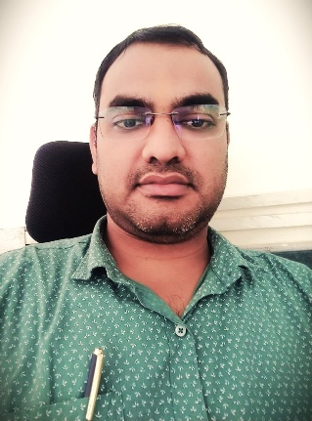Linkedin profile link | Dr. Durga Prasad Mishra holds a strong and diverse academic background as a double bachelor’s degree holder. He completed his bachelor’s degree in mathematics and physical science from Acharya Nagarjuna University (ANU), Andhra Pradesh, and earned his B.Tech in Electronics and Communication Engineering from Biju Patnaik University of Technology (BPUT), Odisha. He further pursued his M. Tech in Electronics and Communication Engineering from BPUT, Odisha, strengthening his specialization in communication systems and electronics. He completed his Ph.D. from the National Institute of Technology Rourkela, focusing on the design of chipless RFID transponders for retail and healthcare applications. Dr. Mishra is an academician, researcher, and author specializing in chipless RFID systems, microwave engineering, antenna design, and applied electromagnetics. He began his academic career in January 2011 as an Assistant Professor at Gandhi Institute for Technology Autonomous College, where he contributed extensively to teaching, laboratory development, and mentoring students in Electronics and Communication Engineering. He also served as an Assistant Professor at NIT Rourkela for one year and later gained research experience at the Indian Institute of Technology (ISM) Dhanbad. He is currently serving as an Assistant Professor in the Department of Electronics and Communication Engineering at The LNM Institute of Information Technology, Jaipur. Dr. Mishra has authored and co-authored more than 50 publications in reputed international transactions, journals, books, book chapters, and conferences, including papers in IEEE Transactions on Instrumentation and Measurement and IEEE Microwave Magazine. His international book, Chipless RFID Printing Technologies, published by Artech House (USA, 2024), is a significant contribution to fabrication methodologies and practical RFID implementation. He has received recognition for research excellence, including invited speaker honors at NIT Rourkela and appreciation awards at the International Conference on Range Technology (ICORT), DRDO, India. He has also guided students from foreign universities, including the UK, Australia, and Malaysia. His subject and laboratory expertise includes Microwave Engineering, Antenna Theory and Design, Electromagnetic Fields and Waves, Communication Systems, Digital and Analog Electronics, Network Theory, and Signal Processing. Beyond academic excellence, he is deeply committed to holistic student development, fostering both technical competence and cultural values. Current Research: Radio Frequency Identification, Tag and Reader Design, Antenna Design, RF Systems H/W, RF data analysis and Signal Processing,
Dr. Durga Prasad Mishra
Faculty member

Student members:
Student members
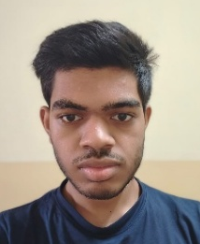  Linkedin profile link | 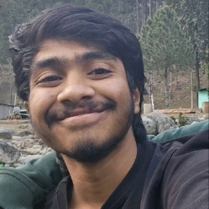Linkedin profile link | Linkedin profile link | 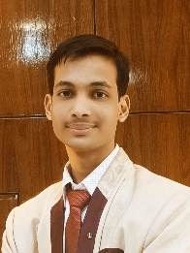  Linkedin profile link
Aryakumar Parmar | Roopeshwar Megadula | Tanushree Sethi | Shivam Agarwal
Chair | Vice chair | Secretary | Assistant Secretary
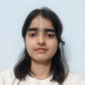Linkedin profile link |   Linkedin profile link | 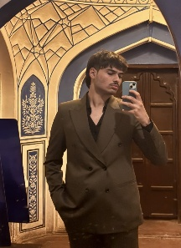  Linkedin profile link | Linkedin profile link
Nandani Sharma | Patel Pratham Bhaveshkumar | Bhavya Pandey | Mudit Goyal
Treasurer | Assistant Treasurer | Webmaster | Student member
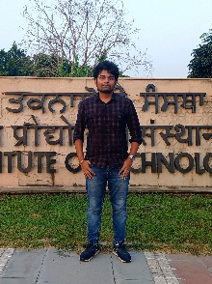 Linkedin profile link | 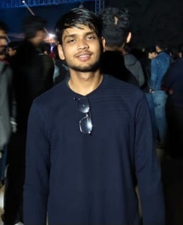  Linkedin profile link
Jayant Chopra | Akshat Agrawal
Student member | Student member

Contact:
LinkedIn Page: https://www.linkedin.com/company/ieee-aps-student-branch-chapter-lnmiit/
Contact email: ieeesbc.aps@lnmiit.ac.in
Faculty Advisor: gopinath.samanta@lnmiit.ac.in
Student Chair: 24dec016@lnmiit.ac.in

